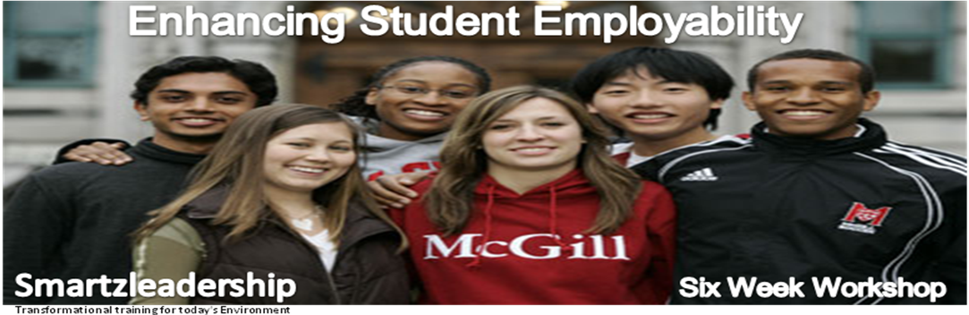
Course Overview
Employers are increasingly finding that despite their formal qualifications many young people leave school / college unable to communicate effectively, work well in teams, and lack initiative and the ability to foresee and resolve problems. In essence, they are deficient in the soft skills that are necessary to ensure their growth, employability and success in the workplace and throughout life.

Employers agree that an employee’s formal qualification is just the basic requirement as each job requires a unique set of employability and technical skills. When deciding on suitable candidates, employers suggest that candidates, who demonstrate employability skills, stand a better chance of being chosen over a competitor with the same formal qualifications.

This, six (6) week programme, will illustrate to its participants the benefits of effective communication, team working, relevant problem solving, appropriate scheduling and self management. The workshop blends theory and practices with a role play session to enable course participants to apply the taught skills in a practical ‘life’ scenario.

The workshop aims to provide young people with a ‘tool kit’ of the life skills essential in gaining and sustaining employment. The session provides participants with an overview of the 15 Emotional Intelligence Competencies which, when used in context, will provide them with practical resources which can be applied effectively to support them both in the workplace and throughout life.

Course Objectives
At the end of the course, participants should have obtained:
- The ability to develop a personal action plan and an understanding of the 15 Emotional Intelligence Competencies.
- Practical communication skills, initiative and a ‘can do attitude’.
- Practical experience of how to effectively work in teams and plan for the workplace.
- Practical ‘role play’ experience of coping successfully and unsuccessfully in a simulated work place environment. There will be scope for sending participants to actual places of work.

Key Facilitator
Abiola Ajayi-Obe
Has a proven track record in Adult and Adolescent leadership, behavioural management strategies & team building utilising Emotional Intelligence strategies that enable individuals and organisations to achieve their full potential.
She is trained and certified on Baron EQi, an instrument used to assess emotional intelligence, and has won several business awards, appeared on BBC Dragons Den, Working Lunch, Ben TV and numerous radio appearances.

For a fuller description of Abiola experience and testimonials please see attached Profile and Testimonial.

Target Participants
The course is aimed at Senior Year students’.

Course Duration
This course is scheduled to run for six weeks and exposes participants to key employability skills in a practical and interactive way.

Course Fee
Dependent on whether the course is delivered on a on a two hour, half day or daily arrangement. To schedule or confirm your booking, please contact Clare Lock on 01992 878333

The Smartzleadership Team
Web: www.smartzleadership.co.uk
clare@smartchartz.eclipse.co.uk
45 Deacons Hill Road, Elstree
Hertfordshire, WD6 3H

