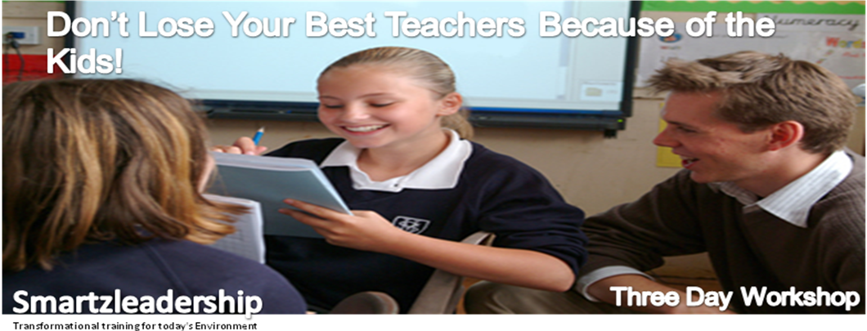
Course Overview
Success and performance in the classroom requires more than just good teaching skills and experience, both of which have served teaching professionals well in the past. To succeed in today’s challenging environment, teachers require a new set of skills for understanding and positively managing children’s behaviour in a classroom setting.

These skills require an understanding of how children’s behaviour and development are shaped as a reaction to rewards, punishments, stimuli, and reinforcement. The workshops identify skills, which influence the attitude and behaviour of children and provide strategies, which help create positive classroom environment.

Spread over 3 days the workshops aims to empower participants with the appreciation of children’s behaviour and associated learning styles. Each workshop provides participants with practical leadership skills to successfully manage children’s behaviour in a group setting.

Module One
Aimed at Junior level staff and Teachers new to the teaching fraternity who would like to acquire essential practical strategies to enable them to manage classroom behaviour much more effectively and facilitate effective teaching and learning.

Module Two
Aimed at existing teachers the workshop delivers a practical tool kit of strategies to enable them to effectively engage with their students and motivate them towards planned learning outcomes.

Module Three
This is a bespoke programme developed to address specific challenges and issues faced by your teaching team. There is sufficient opportunity, in this module, for particular members of staff to have a one-to-one session with the facilitator.

Course Objectives
At the end of the course, participants should be able to:
- Build on past training and put these all together in a ‘tool kit’ which allows them to effectively manage children’s behaviours within a classroom setting.

Key Facilitator
Abiola Ajayi-Obe
Abiola has extensive experience in the delivery of Teacher training and adult leadership courses and a proven track record in leadership techniques behavioural management strategies & team building utilising Emotional Intelligence strategies that enable individuals and organisations to achieve their full potential.

Her workshops are engaging, fun and include a wealth of valuable advice. Packed full of role play, and discussions around real issues, which teachers have to deal with; the strategies provided promote good behaviour, enthusiasm and focus from children.

Course Duration
This course is scheduled to run over three days.

Course Fee
A fee of £2500 plus VAT (£2875) is payable and covers course material, for up to 30 participants. For each additional participant over 30 a fee of £49.99 is payable. To book your place, please contact Clare Lock on 01992 878333

The Smartzleadership Team
web: www.smartzleadership.co.uk
clare@smartchartz.eclipse.co.uk

Location
The training is held in-house at your preferred location
45 Deacons Hill Road, Elstree
Hertfordshire, WD6 3HZ

